**Freeman chain code**

**Purpose**

Use the direction to determine the shape of objects.

**Introduction**

Curve points are selected according to where the curve intersects the mesh lines between adjacent nodes. Each place the line drawing intersects the mesh, the mesh nodes associated with the mesh line are considered. The node which is closer to the intersection is selected as a curve point. When there is more than one intersection point around the mesh node, only one curve point is chosen. The sequence of magenta dots arises from this process as shown in the figure below.

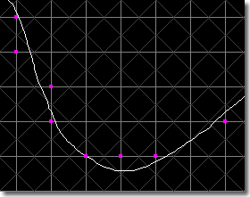

**Metholody**

It likes the way when we draw the thing. We need to imagine that the paper has the system of directions. The points of a compass. Here we have a range of eight different directions that we can use to tell people how they are to 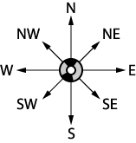move.

*Using numbers in writing chain codes*

We replace direction symbols by numbers and apply the algorithm below.

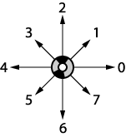Let’s examine the example below. We start at top point move to left and get the numbers like example in image.

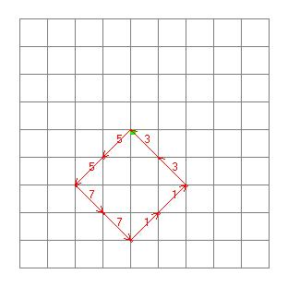

**Use freeman chaincode in human body extractor**